**CORS**

A JavaScript application running in the browser can usually only access HTTP resources on the same domain (origin) that serves it.

Loading images or scripts/styles always works, but XHR and Fetch call (RestFull Services call) to another serve will fail, unless that server implements a way to allow that connection.

This way is called CORS, Cross-Origin Resource Sharing.

One very important thing that needs CORS is ES Module, recently introduced in modern browser.

If you don't set up a CORS policy on the server that allow to serve 3rd party origins, the request will fail.

Fetch example

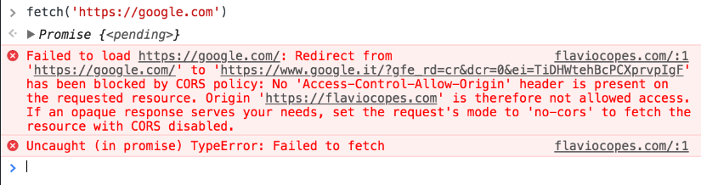

**XHR Example**

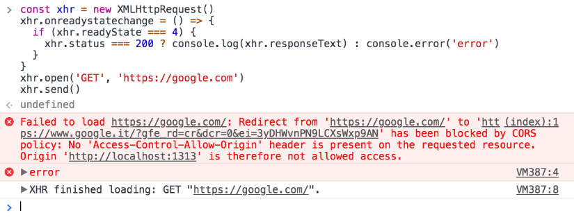

A Cross - Origin resource fail if it is

1. To a different domain

2. To a different subdomain

3. To a different port

4. To a different ptotocol

And it is there for your security, to prevent malicious users to exploit the Web Platform.

but if you control both the serve and the client, you have all the good reasons to allow them to talk to each others.

Without Cors Origin

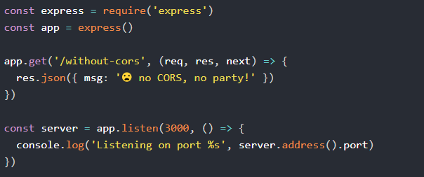

With Cors Origin

